Final Project External Comments

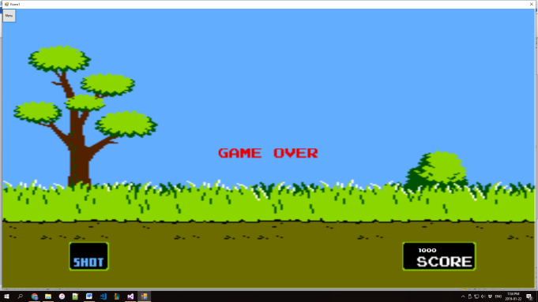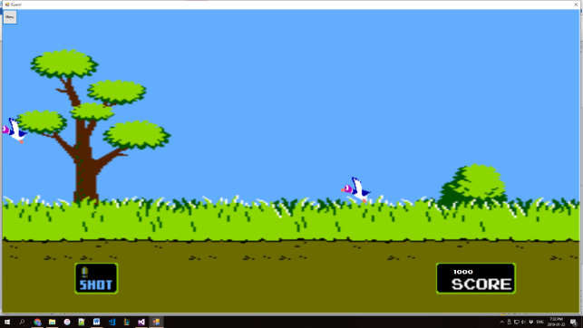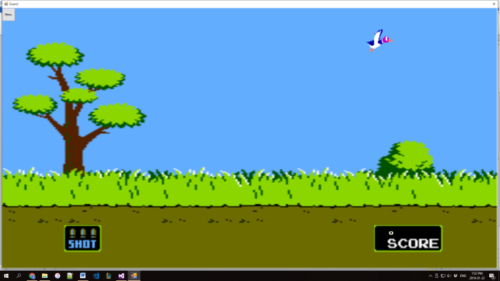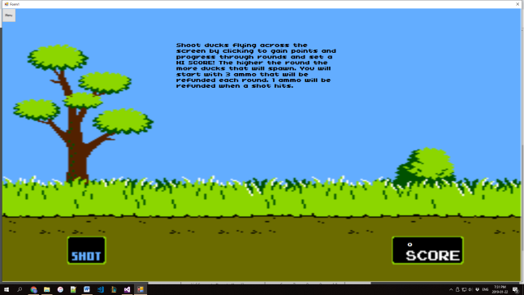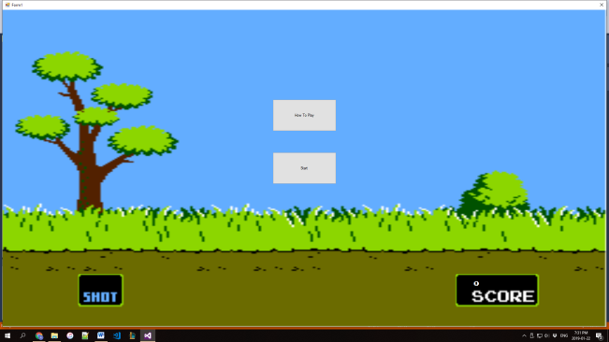The program displays a menu containing two options, how to play and start, clicking the how to play button will remove the two buttons and display text explaining how to play as well as a menu button in the top left corner that returns the user to the main menu when clicked. Clicking the start button will cause ducks to start spawning for the user to shoot by clicking on and give the user three ammo, one ammo is refunded for each kill. However, ammo cannot exceed three and will be replenished after each round. With each kill the users score will increase by 250 points. Once the user runs out of ammo, a game over message will appear on the screen and the user can return to the main menu by clicking the menu button in the top left corner. If the user breaks the hi score, the current hi score will be replaced in a text file. The in game GUI consists of two components, one showing the remaining ammo, and the other showing the users current score. The only error is that hi scores are only updated after a game over is achieved. Therefore if a hi score is obtained, but the user clicks menu before running out of ammo, the hi score will not be updated.